Our FOCUS

Providing EDUCATION

CLEAN WATER

SUSTAINABLE LIVING

VOCATIONAL TRAINING

HOUSE BUILDING
TRANSPORTATION


Disease Prevention

Sewing For Hope

Future goals

Providing education
Education is essential for the future of these children and without it they will never be able to break the cycle of poverty. Although elementary education is free in Tanzania, students are required to buy their own school uniform, paper, books and pencils. As the average annual income per family is only $95, most children simply can’t afford the required items. Tumaini supplies each AIDS orphans with school uniform, books and pencils for getting to school and everyone in the household gets 2 sets of clothes and a mosquito net ($10 cost). Malaria is the biggest childhood killer in Sub-Saharan Africa, while repeated episodes of malaria threatens the lives of immuno-compromised parents.

A gift of a solar lamp ($25 cost) to as many families as possible enables craft-work for income and homework to be completed after nightfall. Currently the Tumaini Fund provides the means of education to 25,000 deserving orphans. Only the top 10% of children finishing elementary school are eligible for Secondary School and the Tumaini Fund provides the annual fees and school supplies for all orphans in Kagera who achieve this level.

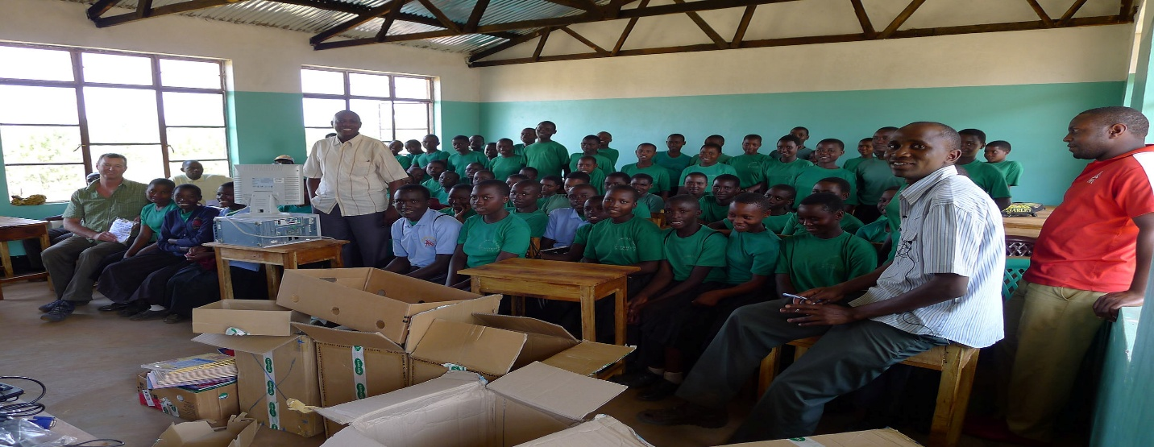

Clean Water
Worldwide, 4500 children die every day from dirty drinking water. It is estimated that of the 900 million people living in Africa, 288 million people lack access to clean drinking water. African children are 240 times more likely to catch diarrhea than kids in developing countries, many of them subsequently dying. 24,000 children under five years of age die in Tanzania each year. Water sources are foul and a long way from the villages and such water is used for cleaning and cooking, and the ponds are used by animals and humans alike. Dysentery is common. Infant mortality in Kagera is 12%: 12 infants in every 100 born die before 1 year of age, usually due to gastroenteritis

Water wells are life saving for these children. Clean drinking water greatly improves their health and prevents them from having to risk their lives to retrieve dirty water from water holes shared by crocodiles and snakes. A shallow well at a cost of $5,000 can provide clean water for an entire village. Over the past 14 years the Tumaini Fund supporters have donated funds to build over 60 shallow and deep wells.

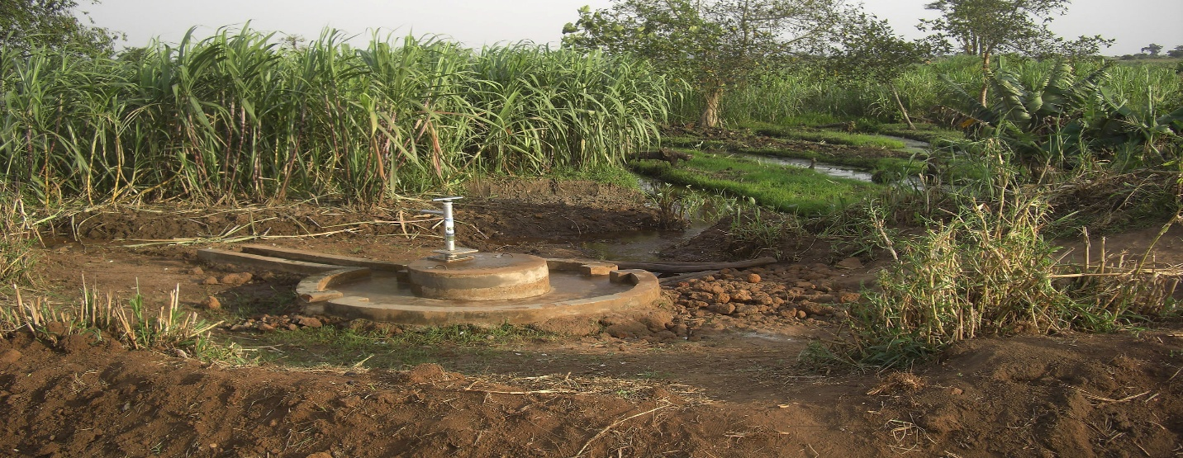

Sustainable Living
Subsistence farming is how most of the families in the Kagera region survive. With climate change and unpredictable rains, crops, such as maize, are often planted but die before harvest due to lack of water. As recently as September 2016, the region experienced a severe drought and Tumaini responded to the famine by appeals for donations to bring in food supplies to be distributed by Tumaini parish workers to the neediest families.
Irrigation is needed to alleviate inconsistent water availability for farming. One project recently completed in Kibehe (2015), funded by a Naples, FL couple through a donation to Tumaini, consisted of two large above ground storage tanks filled with water pumped from a well by a solar powered pump. Those tanks feed taps that are linked to irrigation pipes that are laid in the crop fields. The taps are turned on when the fields need water. This has led to a huge increase in the crops produced. The outcome of this project has been to bring health and economic benefit to 500 people in Kibehe and the surrounding area. The project was so successful that the community would like 3 additional water towers to expand the area under production.
​
With reliable water for irrigation other crops, such as coffee, could be grown with an assurance of a harvest that could be counted on to provide a marketable produce and a boost economically to many families.

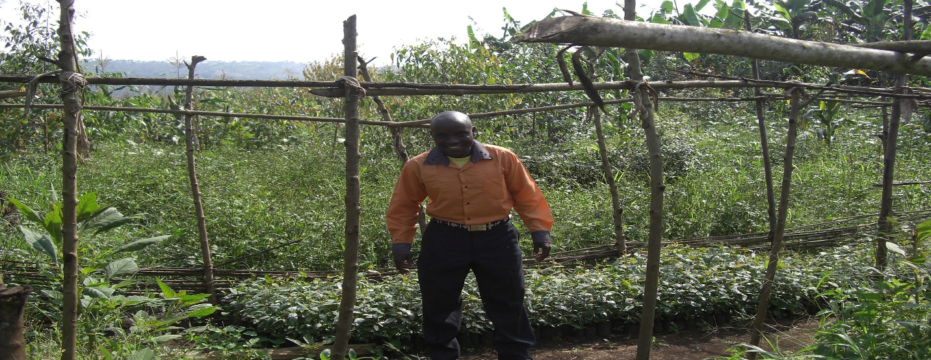

Vocational Training
Vocational training is a key focus of the Tumaini Fund’s support in Kagera. Tumaini has 2 vocational training schools, one for tailoring and a workshop for carpentry training, mainly for orphans who leave after primary school. Wood shutters and doors for the new houses being built can be made by local carpenters. Mud fired bricks are also produced locally as a vocation for some orphans.
​
Throughout the area families have been helped by Tumaini to set up micro financed businesses such as rearing chickens, goats, cows or bee keeping and fish ponds. As part of the larger educational effort to enable persons to obtain life skills to be productive members of their community, vocational training is a very important option. These projects are funded by Tumaini and available to AIDS widows and widowers who seek an alternate income to subsistence farming. They are often small joint community projects.
​
Tumaini loans the start-up costs for the business and this loan is repaid from later profits at low interest rates, usually 1% or 2%, with a maximum of 5% for high risk ventures.

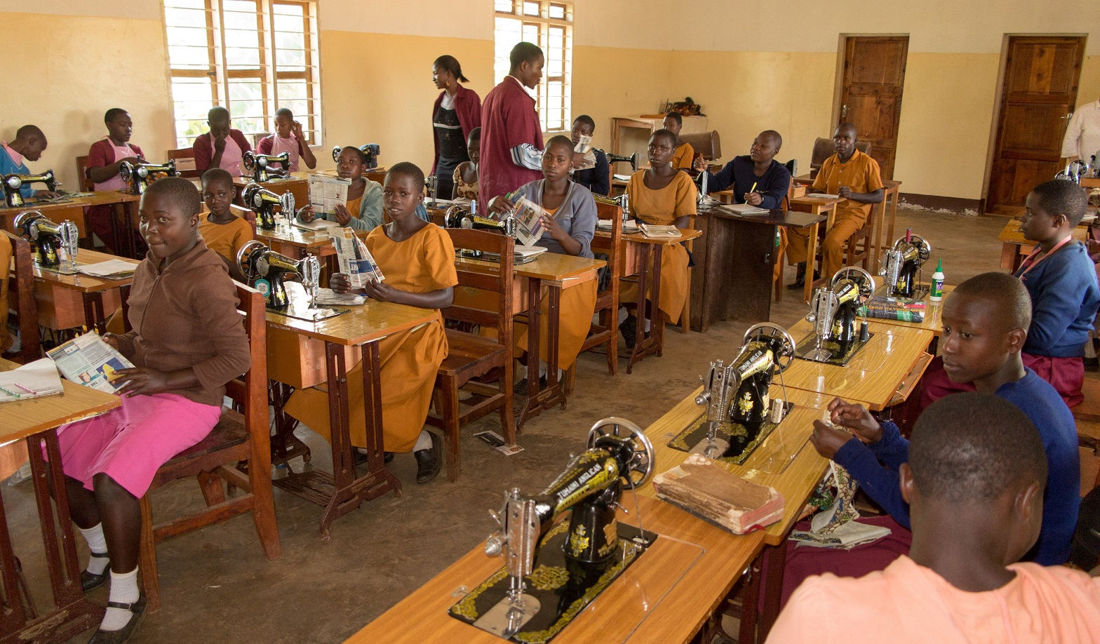

House Building
Housing is basic wattle and daub, clay or dung, and the roofs of grass or
banana-leaves cannot withstand the heavy rains that occur twice a year. Whole
families share a single room and cooking in the same house creates a real health
and fire hazard. In the rainy season, the heavy downpour leaks through the roof and the
family simply stands and waits for the rain to cease and the floor to dry before they can lay
bedding on the ground to sleep. With a house of sticks and leaves, there is danger when
water accumulates in the roof leaves and the weight causes the roof to collapse, killing the
family huddling inside..... a reality and desperate worry for many families. There are few
facilities for the collection of seasonal rainwater.

There is a constant need for new housing in Kagera where so many families exist in the most
terrible homes, often constructed of sticks and with a roof of leaves. The new homes constructed by Tumaini for a cost of $1200 have the following specifications:
​
Foundations: Sand and cement
Walls: Mud bricks, made of clay and soil and baked in the sun OR Fire bricks, made of clay and soil and baked in a kiln
Roofs: Tin sheet
Windows: Wood framed with wood shutters. Mesh screening now being installed on all windows to protect against mosquitoes and malaria.
Doors & Shutters: Made of wood by Wilbroad in Tumaini Vocational Carpentry Workshop.
Design: 2 Doors- one front and one back of the house for ventilation.
2 Doors inside- one for each bedroom.
Rooms: 3 Rooms- 1 bedroom for girls to sleep, 1 bedroom for boys to sleep, 1 room for general living.
Cooking outside: Families are encouraged to keep a small, well ventilated shelter outside their home for cooking. This keeps the new house free from pollution from smoke etc.
Family Pride: Many families work to improve their house, with personal decorations, new bedding and flowers outside, making it truly a family home.
​
To each family, living without hope in a hovel, a new Tumaini house is a priceless gift

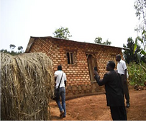
Click Here to View a Home
Built by The Tumaini Fund
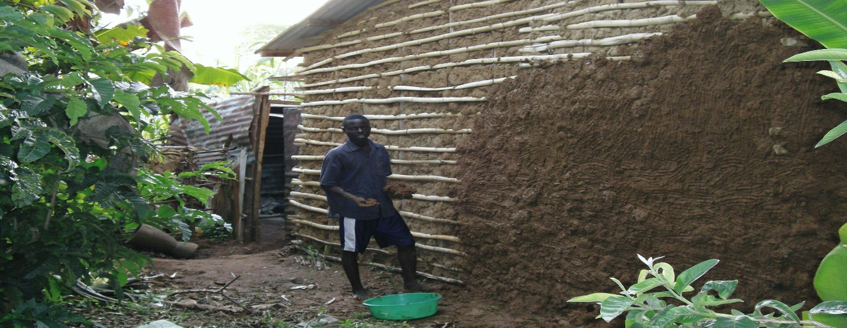

TRANSPORTAtION
Most roads in Kagera are dirt roads and often not much more than a path. The long walk of several miles to school can be a severe handicap to students who arrive home with crops and animals needing immediate attention and essential homework to be done before nightfall. The three-mile walk to and from school can be replaced with a bicycle ($100 cost) thus saving them an average of two hours per day. As a result, the students have more time for homework and more sleep; thus their grades improve dramatically. Competition is fierce to own a coveted bicycle with thousands who need one and few available. Bicycles are awarded to the neediest students after written applications from all students are evaluated.

Since formation in 2003, Tumaini has established four offices in Kagera from which any of the
180 social workers can service the needs of widows and orphans in the surrounding parishes.
The four offices, kayanga, Muleba, Chato and Murgwanza are separated by large distances
and the lack of transportation can be a major obstacle to providing Tumaini services to those in
need. In addition to bikes, a motorcycle which costs $3,000, can provide a huge time saving
benefit to those social workers in their effort to visit the surrounding parishes. The one relatively
new four wheel drive land cruiser and one older rebuilt one are the only vehicles presently
available to transport larger numbers of people and supplies over those large distances. On the
wish list of Tumaini fund is the purchase of a desperately needed third vehicle (up to $45,000 for a Toyota Land Cruiser).

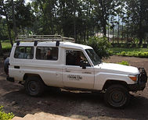
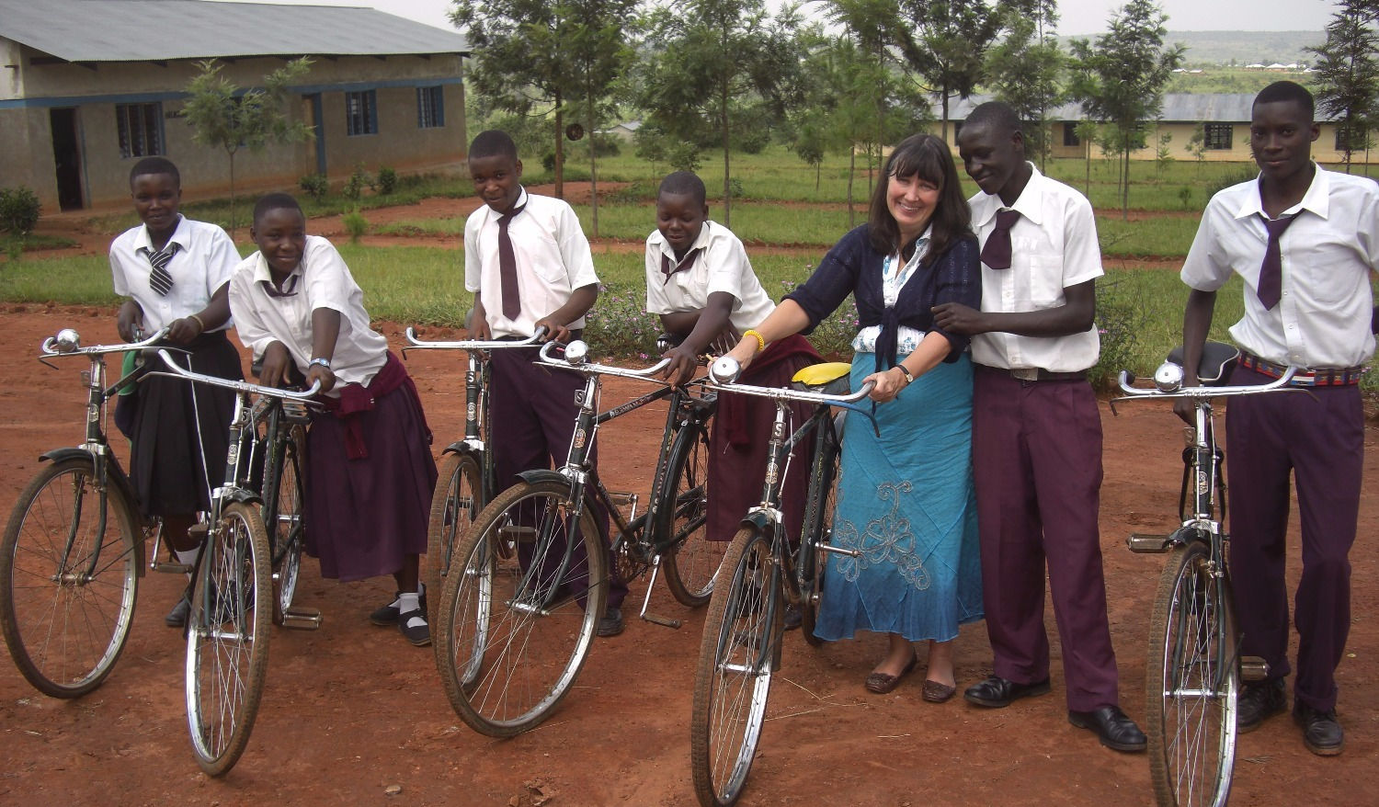

Disease prevention
Every year malaria, a parasitic disease spread by the bite of a mosquito, results in 300 million to 500 million clinical cases and causes more than 1 million deaths worldwide. Mostly it is young children under the age of five in sub-Saharan Africa, including Tanzania, who are affected, dying at the rate of nearly 3,000 every day. In Africa, malaria causes approximately 20 per cent of all child deaths. Some children suffer an acute attack of cerebral malaria that quickly leads to coma and death; others succumb to the severe anemia that follows repeated infections, or to the consequences of low birthweight caused by malaria infection in the mother’s womb. Those children who escape death are not untouched by the disease. Malaria also hinders the development of those who survive. In sub-Saharan Africa, the disease is responsible for 30 per cent to 50 per cent of all outpatient visits to clinics and up to 50 per cent of hospital admissions. Malaria contributes to increased maternal morbidity and mortality. Malaria during pregnancy is the major cause of low birthweight in sub-Saharan Africa. The disease also has a crippling effect on the continent’s economic growth and perpetuates vicious cycles of poverty. It costs Africa US $10 billion to $12 billion every year in lost gross domestic product.

Protection from malaria carrying mosquito bites is a top priority for Tumaini and thousands of mosquito nets have been provided to families to cover their beds at night. In Tanzania, more than 26 percent of all outpatient attendances are attributable to malaria, resulting in an estimated 7.7 million confirmed and clinical malaria cases annually. Plasmodium falciparum is the main source of infection in Tanzania. New mud brick homes that are being built have mosquito protection on the windows.

Having access to clean treated water can eliminate the many water borne diseases affecting the families. 24,000 children under five years of age die in Tanzania each year, often attributed to dirty, contaminated water. Sources can be contaminated with fecal and total coliform. A treatment system will filter out and treat viruses, sediments and bacteriological contaminants from the water.

It is estimated that worldwide 2.4 billion people are living without a toilet. Diarrhea caused by poor sanitation and unsafe water kills more than 300,000 children worldwide every year. Disease transmission at work, mostly caused by poor sanitation, causes 17% of all workplace deaths. Tumaini is working toward providing healthy toilets, first in schools then later to public places.

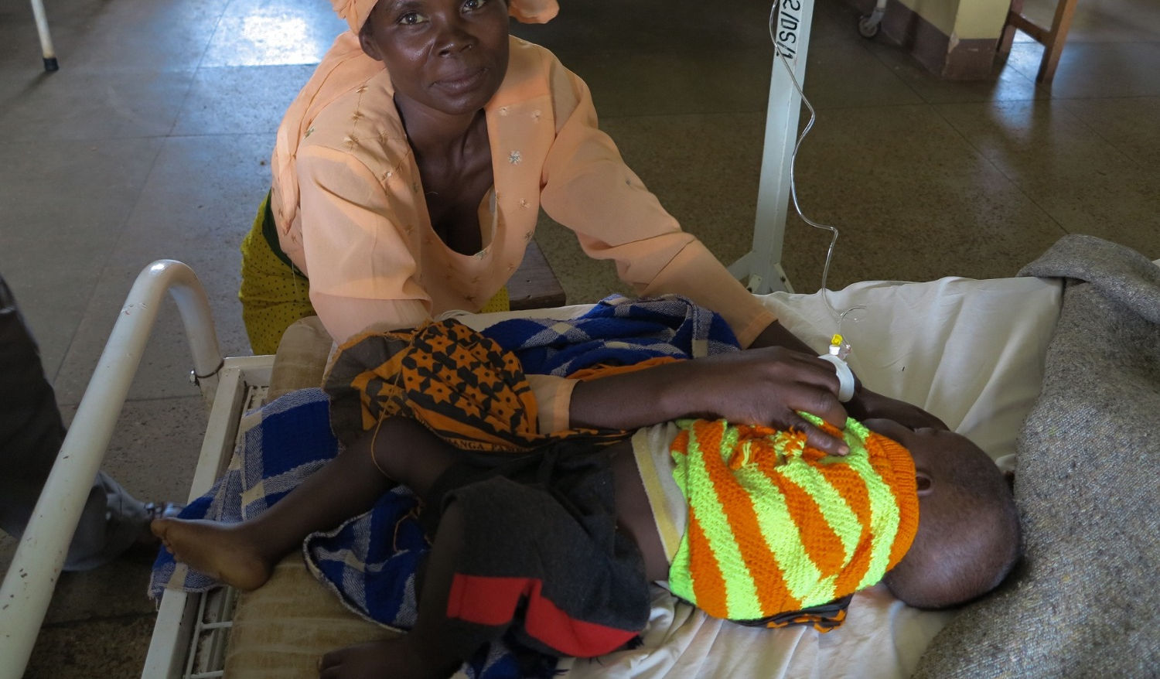

Sewing for hope

A PROJECT OF tumaini fund usa
The mission of Sewing for Hope is to bring love, joy, and dignity to the orphans of the Tumaini Fund by providing them with a new, hand-made dress and coordinating t-shirt. In addition to dresses, the orphans need sweaters to keep them warm as the nights can be quite cold in Tanzania.

The orphans in the Kagera region of N.W. Tanzania have only rags to wear. Most of these children
have lost one or both parents to the AIDS crisis. Their lives are full of sorrow and struggles.
Receiving a new dress may sound trivial to many of us; however, these clothes bring great joy and
pride to these orphans. They are truly a blessing as they receive the knowledge that each dress is
stitched with love and prayers especially for them. With this gift the children are eager and willing
to venture out in society with dignity and they can now go to church where they would not go
wearing only their rags as they feel that is dishonoring God.

There are many individuals, churches, women’s clubs, and other groups who have joined the
ministry of Sewing for Hope since its inception in 2009. We are growing and producing more
dresses than ever before. As of January 2017, we have sent approximately 3500 dresses and
countless sweaters to Tanzania!

Sewing for Hope headquarters are in Naples, FL. However, there are volunteers and SFH branches in other parts of the United States, including Massachusetts and South Carolina, who sew dresses and knit sweaters for the orphans. If you would like to share your love and talent by making a piece of clothing and to help make the world a better place for these children, please join us!

Visit our website at www.sewingforhope.com for more information or email us at info@sewingforhope.com

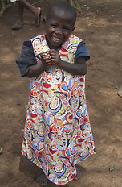
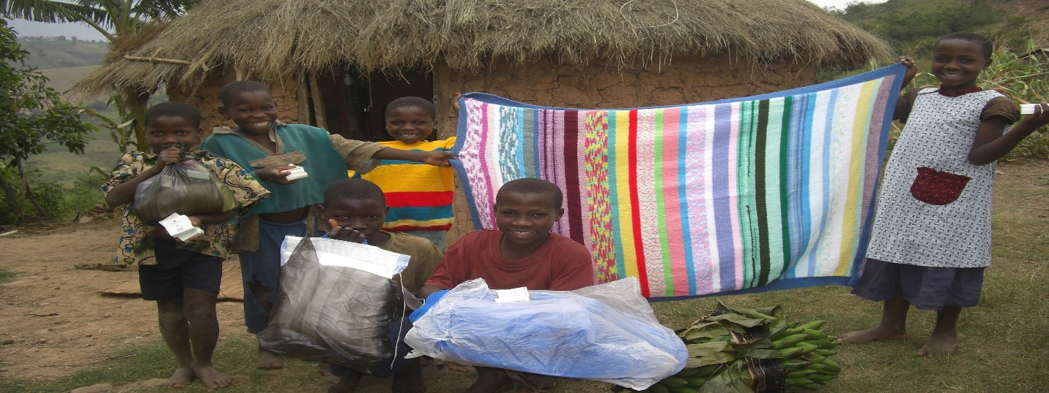

fUTURE GOALS
Tumaini Fund USA / UK are once again participating as partner organizations with the Naples North Rotary Club, the Rotary Club of Karagwe, and Water Mission - Tanzania in a follow-on Rotary Foundation Global Grant to expand the capabilities of the phase 1 Rotary water distribution project successfully completed in Katembe, Tanzania in October 2017. The phase 1 completed project is now providing clean, treated water to more than 3,500 people in 6 villages, 3 schools and 2 churches over a 7-mile distance. The new phase 2 project will expand the pipe line and capacity of the existing system by quadrupling the water storage capacity to 40,000 liters and adding 7 new taps in areas not presently being served. Hand washing stations will also be installed at several schools as part of a WASH (water and sanitation hygiene) program. It is expected that the number of people using the expanded water system will increase to more than 4,800 persons.
​
The Global Grant application has been completed and submitted to the Rotary Foundation. Work is planned to start in July 2019 by Water Mission - Tanzania pending approval of the grant by the Foundation. Tumaini staff in the Karagwe area will monitor the progress of the project and help assess the impact on the quality of life of the users. They will also be able to check project sustainability once the expansion is completed.


